USB Multi-Megapixel Web Camera
with Microphone
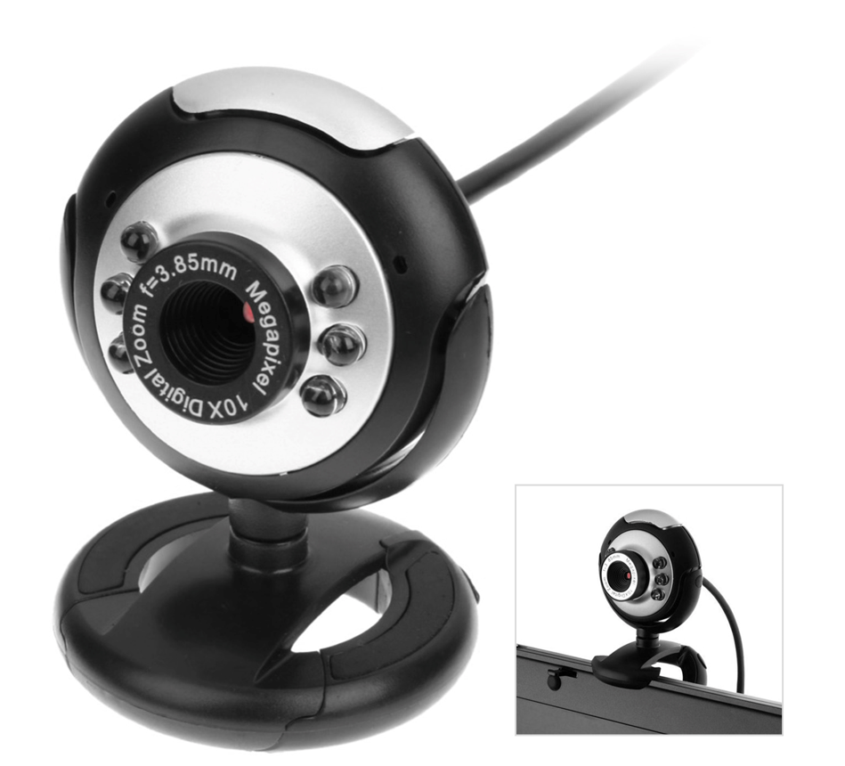

Introduction:

The new Dynamode multi-megapixel USB2.0 Web Camera is your ideal solution for quality Video and Audio Communications across the Internet or across your own personal Network. With up to 10 Megapixel performance (with Software Enhancement) it features the latest in high-definition Optics so to fully realise the latest in Computer communications, the Dynamode M-1100M also combines a quality internal Microphone so as to further reduce clutter on your Mobile or Desktop Computer.

Compatible with Microsoft® WindowsTM including Windows7TM and also compatible with popular Internet Communications such as SkypeTM, MSNTM and YahooTM the new Dynamode M-1100M is your ideal solution for your Digital Lifestyle.

Specification
High-defintion Multi-Megapixel HD Optics
Up to 10 Megapixels (with Software Enhancement)
Built-in Microphone
Faster Optics for low light conditions
EasyClip - allows attachment to Notebooks, TFT Screens
Snapshot button for instant picture taking
High-speed USB2.0 Interface, Plug n' Play
Advanced automatic Colour Compensation facility
Manual focusing from 5cm to infinity
Up to 30fps at 640x480 (CIF)
Video format: 24-bit RGB
Compatible with Microsoft® WindowsTM XP/Vista/Windows7
Compatible with SkypeTM, MSNTM and YahooTM

